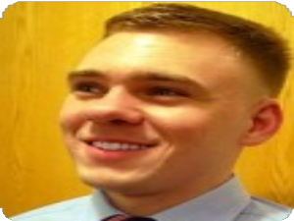

**NICHOLAS STEVENS**

TECHNICAL SUPPORT ENGINEER



CONTACT

[](mailto:nstevens@nanick.org) [NSTEVENS@NANICK.ORG](mailto:nstevens@nanick.org) [](mailto:nstevens@nanick.org)   
 [](tel:1-224-223-2299) [(224) 223-2299](tel:1-224-223-2299) [](tel:1-224-223-2299)

[](msteams://l/chat/0/0?users=nstevens@nanick.org) [NSTEVENS@NANICK.ORG](msteams://l/chat/0/0?users=nstevens@nanick.org) [](msteams://l/chat/0/0?users=nstevens@nanick.org)   
 [](https://www.linkedin.com/in/nicholasstevens312) [IN/NICHOLASSTEVENS312](https://www.linkedin.com/in/nicholasstevens312) [](https://www.linkedin.com/in/nicholasstevens312)

[NSTEVENS1040](https://github.com/nstevens1040) [](https://github.com/nstevens1040)



[1027 FISH HATCHERY RD APT 302, MADISON, WI 53715](https://www.google.com/maps/search/?api=1&query=Google&query_place_id=ChIJRQe7mkKtB4gRxM0zTL1esVQ) [](https://www.google.com/maps/search/?api=1&query=Google&query_place_id=ChIJRQe7mkKtB4gRxM0zTL1esVQ)  
 [](https://resume.nanick.org/) [RESUME.NANICK.ORG/](https://resume.nanick.org/) [](https://resume.nanick.org/)



SUMMARY

### A+ certified technical support engineer with seven years of experience delivering knowledgeable, detailed, and expeditious best practice technical support to staff at every level of seniority. I take pride in my ability to quickly and effectively resolve issues under pressure while minimizing or eliminating disruptions to production. My diverse IT background empowers me to deploy and support the hardware and software solutions that meet the unique technological needs of your business objectives. I intend to take on a role with a firm where a relationship of mutual development, advancement, and growth can be established.



EXPERIENCE

[**COMPASS LEXECON**](https://compasslexecon.com/)*12/2016 - 10/2019*

## TECHNICAL SUPPORT ENGINEER I

### Compass Lexecon is a global economic consulting company with headquarters in Chicago, Illinois.

* Tested and monitored videoconferencing between practitioners and client law firms to ensure that important video calls went uninterrupted
* Generated daily reports relating to user sessions on Windows servers which enabled me to prevent common issues with Citrix Application Delivery
* Increased stakeholder confidence by ensuring stellar service delivery and documenting incident resolutions in ServiceNow per ITIL
* Resolved unique interoperability issues between statistical analysis software (STATA, R, MATLAB, Python, etc.) and Microsoft SQL Server
* Produced on-demand reporting for database backup restore operations to allow practitioners to begin analysis as soon as possible
* Wrote knowledge base articles that worked to reduce incidents by giving staff reliable resources during six major deployments, migrations, and upgrades
* Improved and hastened user account provisioning by automating the process of determining which AD security groups a new user must be added to
* Gained approval from IT governance to write a PowerShell script for use in production as SOP to configure new laptops and append a provisioning log
* Managed the secure ingestion of highly confidential and/or federally protected data sent from client law firms

[**BURWOOD GROUP**](https://www.burwood.com/)*06/2016 - 09/2016*

## ON-SITE HELPDESK STAFF AUGMENTATION FOR STARWOOD RETAIL PARTNERS

### Burwood Group is a consulting firm that bridges business strategy and technology solutions.

* Prevailed over incident response and full resolution SLA targets by delivering swift and competent service to 100 local users and 200 remote users
* Improved equipment provisioning process by automating required changes to user profiles with a Batch script
* Reduced hardware overhead by providing break/fix solutions for laptops, desktops and associated peripherals
* Exceeded progress targets for their endpoint migration initiative from Microsoft Office 2010 to Microsoft Office 365
* Single point of contact for technical support to both local and remote staff with very few escalation points

[**PROJECT LEADERSHIP ASSOCIATES**](https://www.neweratech.com/us/)*02/2016 - 05/2016*

## REMOTE SUPPORT FOR COCA-COLA MULTITENANT MIGRATION

### Project Leadership Associates (now New Era Technology) works with customers as a trusted technology adviser.

* Proactively scheduled Bomgar remote support sessions with Coca-Cola staff, post cutover, to reconnect their Outlook profile to Exchange Online
* Outperformed SLA while following best practice incident management in ServiceNow
* Worked closely with escalation teams to determine whether resolutions can be resolved client-side or if they require changes in Exchange Online
* Decreased time spent troubleshooting by contributing to a knowledge base upon discovery of working resolutions
* Minimized the need to escalate incidents by successfully resolving them at the endpoint

[**INNERWORKINGS**](https://www.hhglobal.com/)*04/2015 - 01/2016*

## HELPDESK SUPPORT TECHNICIAN

### InnerWorkings (acquired by HH Global) is a global professional services firm focused on marketing execution.

* Worked alongside four other helpdesk technicians to support over 2000 users worldwide in 80 countries
* Continually improved full resolution time by contributing to a knowledge base and working with the Systems team to push solutions for common issues
* When appropriate, performed repairs to reconcile computer hardware which saved the firm over $100K in 9 months
* Hardened endpoints by collaborating with Systems to deploy Snow Asset Management to manage security compliance
* Ensured that Globalscape MFT was smoothly implemented by migrating folders from the old FTP solution as well as educating non-technical staff on its use

[**TIGERDIRECT**](https://www.tigerdirect.com/)*11/2012 - 04/2015*

## LEAD TECHNICIAN

### TigerDirect is a California-based retailer dealing in electronics, computers, computer components, computer repair, and custom-built PCs.

* Took on nearly any computer repair challenge as a way to increase revenue, to increase customer confidence, and to gain experience
* Drove profitability by building custom made-to-order desktop PCs as a core function of my role
* Took ownership of customer outcomes to support the reputation of the technical services department Provided oversight and mentorship for four technicians working under me
* Directly influenced a nearly two-fold increase in revenue from technical services



EDUCATION

# [WILLIAM RAINEY HARPER COLLEGE](https://harpercollege.edu/)

COMPLETED - ASSOCIATE IN ARTS

# [COMPTIA A+ CERTIFIED](https://www.certmetrics.com/comptia/public/verification.aspx)

## VERIFICATION CODE: 237SZ1W1XP4QY50N

EXPERT



SKILLSET



ADVANCED

*08/2008 - 05/2012*

*COMPLETED - 05/2008*

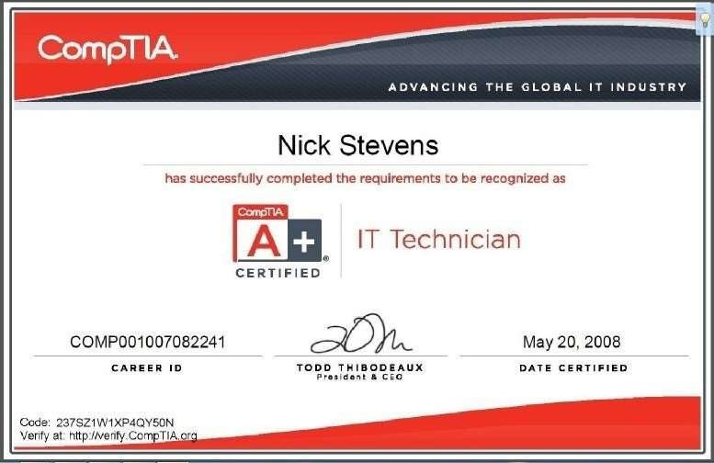

Windows 10 Windows PowerShell

Laptop and Desktop Full Service Repair Custom Made-to-Order desktops

INTERMEDIATE

Azure Active Directory Windows Server 2012/2016 Windows Group Policy

Unix Shell Commands and Scripting Debian GNU/Linux

macOS

H.323 Videoconferencing Gateway Batch scripting

HTML

JavaScript Python scripting

Citrix Application Delivery Citrix Workspace

VMWare AirWatch Mobility Management Bomgar Representative Console

ITIL

Zendesk Incident Management

Microsoft Office 365

Active Directory Users and Computers Microsoft Exchange Server

Polycom Videoconferencing IP Phones

LAN, WAN, VLAN, DHCP, and DNS

Printers, Scanners, and Multifunction Printers Network Printers

Apple Hardware Diagnostics and Repair C# (.NET Framework)

PowerShell Core

ServiceNow Incident Management LANDesk Asset Management Ivanti Asset Management

BASIC

Microsoft SQL Server Administration Ubuntu

IBM AIX

Office VBA

Visual Basic Scripting Edition VMware ESXi

VMware vSphere Hypervisor BMC Remedy

SCCM

Snow Software Asset Management